Light- Energy in the form of waves that the human eye sees as visible light

Refraction- To bend light rays as they pass from one substance into another; such as from air into water

White Light-The mixture of wavelengths of various colors that appear colorless, like sunlight

Prism-A piece of clear glass or plastic that bends or breaks up light into the colors of the spectrum
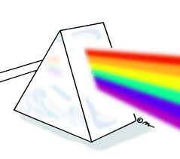

Visible Spectrum-The range of colors, which consist of red, orange, yellow, green, blue, indigo, violet (ROY G. BIV), is known as the visible spectrum. The part of the spectrum which you can actually see.

Electromagnetic Spectrum-is the complete range of electromagnetic waves placed in order of increasing frequency.

