Subtractive Color Mixing- The combining of different colors of pigments where each new pigment used subtracts more colors of light so that fewer are reflected to our eye.
The result of combining all colors subtractively is black.

Pigment- A substance that causes matter to appear colored by absorbing certain colors of light that strike it and reflecting others.

Primary Colors- Three colors that can combine to make any other color
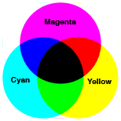

Secondary Colors- Two primary colors combined in equal amounts make a secondary color.

Example: magenta + cyan= violet
magenta + yellow = orange
cyan + yellow = green

