Law of Reflection- The scientific law stating that light rays reflect (bounce) off a surface at the same angle at which it hits but in the opposite direction.
Orientation-The direction (reversed, upside-down, etc.) of something
Beam- A beam is a group of closely related rays. (A beam can also be used to mean one ray).
Reflect- To bounce off a surface.
Concave Mirror- A surface that is curved inward like a bowl and reflects light. The images in this mirror are magnified and appear closer.
Convex Mirror- A surface that is curved outward and reflects light. The images in this mirror appear smaller and farther away.
Converge- When light rays bend together
Diverge- When light rays bend apart
Periscope- An instrument for observation over, around or through an object, or obstacle that prevents a direct line of sight. It uses two parallel mirrors at 45° angles to create an image.
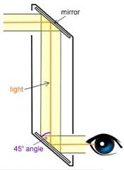

***Mirror Reflection- When an image is reflected into an odd number of mirrors, the orientation of the image is backwards. However, when an image is reflected into an even number of mirrors the orientation of the image is the same. ***

