Color Filters-Substances that allow only certain colors of light to pass through it
Additive Color Mixing- The combining of different colors of light, so called because each new color adds to the total amount of light present. The result of combining all colors additively is white
Primary Colors of Light- Red, blue, and green
Secondary Colors of Light- Cyan, Magenta, and Yellow
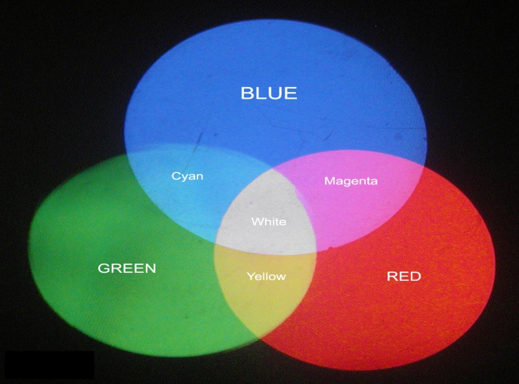
Transparent-Transmits most of the light that strikes it. The light passes right through without being scattered. This allows you to see clearly what is on the other side of the transparent material.
Translucent- Translucent material scatters light as it passes through. This allows you to see through the material but not clearly. The image on the other side would appear blurry.
Opaque- Reflects or absorbs all light that strikes it. You cannot see through opaque material because light cannot pass through them. Opaque materials are able to block light and cast a shadow.
Ray- A narrow beam of light

