Quantitative Observations- Having to do with quantity. Counting the number of items attached to an object. Capable of being measured.
Example: There are 6 legs on a grasshopper.
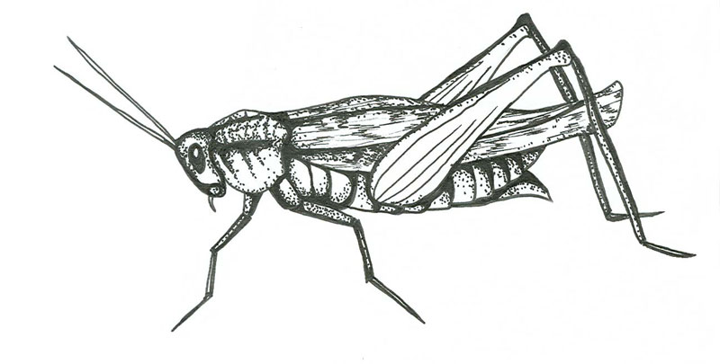

QuaNtitative
N = Number

Qualitative Observations- Having to do with the quality or characteristics of an object. Using your 5 senses to describe an object.
Example: The rock is rough.

QuaLitative
L = Look

Your 5 senses: Sight, Touch, Smell, Hear and Taste
