Light behaves in three ways:

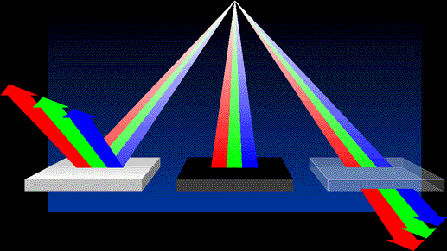

Reflects Absorbs Transmits

of color theory and how it affects the use of your tools.
The key to all discussion of color is how the eye perceives color. In the absence of light, no perception of color is possible. Everything is black. The simplest example of this is demonstrated by walking through a room at night and barking your shins on the coffee table.
If there is light present, the eye can perceive color in one of three ways: as reflected light, transmitted light, or a combination of reflected and transmitted light. Figure 1 shows an example of each of these three possibilities.

